

A PROJECT PROPOSAL

ON

SAJHA BAZAR MANAGEMENT SYSTEM

IN PARTIAL FULLFILLMENT OF THE REQUIREMENTS FOR

THE COURSE OF CT 501 COMPUTER PROGRAMMING

BACHELOR OF ELECTRONICS, COMMUNICATION AND

INFORMATION ENGINEERING

SUBMITTED BY

ARJUN CHHETRI THA075BEI007

SOVIT NEPAL THA075BEI 040

SURAJ AGRAHARI THA075BEI043

SUSHOVAN SHAKSYA THA075BEI046

SUBMITTED TO

DEPARTMENT OF ELECTRONICS AND COMPUTER

ENGINEERING

THAPATHALI CAMPUS

6 JUNE, 2019

# ABSTRACT

Sajha bazar management system is the solution for the practical life problem which makes the customer life easy, convenient in all the matter related to market. It is the most systematic, well managed, easiest, safe, convenient, trustable and quick process to fulfill the user requirement so they don’t have to roam like a bee the search of nectar.

The program mainly deals with user as well as admin. User can buy item that s/he likes take the bills check their prize whereas admin can look at the profit, total product sold and see the person will receive the prize.

**Key Words:**

* *username, product, lprize, bill*

**TABLE OF CONTENTS**

ABSTRACT 1

LIST OF FIGURES 4

CHAPTER 1: INTRODUCTION 5

1.1 Background 5

1.2 Problem Statement .......................................................................................... 5

1.3 Objectives 6

1.4 Applications 6

1.5 Project Features 7

1.6 Feasibility Analysis 7

1.6.1 Economic Feasibility 7

1.6.2 Technical Feasibility 7

1.6.3 Operational Feasibility 8

1.7 System Requirement 8

1.7.1 Software Requirement 8

1.7.2 Hardware Requirement 8

CHAPTER 2: LITERATURE REVIEW 9

2.1 Sajha Bazar 9

2.1.1 User 9

2.2 Admin 9

2.2.1 Add & Remove products 9

2.2.2 Survey 9

2.2.2 Best costumer & costumer of the year 10

CHAPTER 3: METHODOLOGY 11

3.1 Admin 12

3.1.1 Survey the product 13

3.1.2 Choose best constumer 13

3.1.3 Choose costumer of the year 13

3.1.4 View cart 13

3.1.5 View bill 13

3.2 User 13

CHAPTER 4: EPILOGUE 15

4.1 Expected Output 15

4.2 Budget Analysis 15

4.3 Work Schedule 16

REFERENCES.............................................................................................................17

# LIST OF FIGURES

**FIGURE PAGE**

Fig 3.…………………………………………………………………... 12

Fig 3.1.……………………………………………………………….....13

Fig 3.2.……………………………………………………………….....15

Fig 4.3…………………………………………………………………..17

# CHAPTER 1: INTRODUCTION

## 1.1 Background

In this 21st century with the increase in the pace of development in the technological field. Nepal is also heading toward the development in the same way. For any country to be well developed one should be economical strong. This sajha bazar is well managed systemic system that helps to keep the proper deal about economic policy. In our country mostly people are dependent in market to fulfill their daily needs. to buy anything one should go to market roam a lot and they get what they want which is a huge burden. one mayn’t get anything quickly when he or she wants. Still in our country we have weekly market. it means if one has to buy anything he/she has to wait for a whole week and then only one can get those items or they have to buy through the expensive shops.

In this modern era time is money so people prefer such a place where they can buy anything they like they want. Nowadays people prefer departmental store like place. A departmental store is a retail establishment with a building open to the public offer a wide range of consumer’s goods such as clothing, houseware, furniture and appliances .it typically offer a choice of multiple merchandise lines at a variable price point, in different product categories. Economies of large scale buying are transferred to the customer in the form of low prices. Speaking about the pleasant fact we should also speak about the complaint and the replacement. this complain are taken seriously and improved as soon as possible otherwise their market will be down.

Our program sajha bazar management system is a user friendly program the directly interact with the user communicate with them what product they want to buy, obtain bill through it. also one can add items and remove if they don’t like. finally, they obtain a bill in which all the discount and tax will be included also there is a prize system. there a two types of prize one is one is lucky draw system and another one is best customer. this program also communicates with admin; Admin can look at the profit the system is making also the profit per item is also calculated. this help to predict which product is good and makes a lot of profit as well as attract the customer. admin has also the right to who are eligible and getting the prize. User cannot access to this admin portion. This project hence has a lot of benefit not only for customer and seller but also for nation. since there will be official billing system in which all the tax, VAT are included hence it will help to reduce black money and also provides a systematic, proper detail about product sold.

## 1.2 Problem Statement

The main reason which motivated us to create this project is poor management in market. especially in villages and small towns there is the trend of weekly market so the customer has to wait for whole week to buy any product. They have to roam at different place to buy a product which is mostly expensive. but this project overcome this burden. here one can find almost every product under one roof additionally they are with concept of less profit more sale so the product is also a bit cheaper. also they directly contact with the company so the product is also good and cheap for them as well. The main problem of our country is unmanaged economic policy and black money, this project helps to overcome this problem and does task for nation well fair.

## 1.3 Objectives

Its main objective enlightened below:

1. To provide all the goods related service under one floor.
2. To well manage marketing system and economy policy.
3. To maintain healthy relationship with the consumer.
4. To predict the future consumption so that company can gain profit and a brand name.

## 1.4 Applications

This sajha bazar management program can be applicable in different profit making, goods selling institute to well managemnt monetary policy and provide easy service to the consumer which is enlisted below:

1. Supermarket
2. Departmental store
3. Grocery store
4. Bhatbhateni
5. Clothing store
6. Retail company

## 1.5 Project Features

I. It will direct communicate with user to buy goods II. one can add or delete items which s/he has to buy.

1. It will give suggestion to buy the item which s/he might forget to buy.
2. It will make bill automatically of the product bought.
3. It has also feature of prize i.e. lucky draw and customer of the month.
4. It also allows the admin to look the amount of product sold and profit from it.
5. It allows the admin to know who will receive the prize.
6. It will display message the message to the admin if the products are less than certain amount

## 1.6 Feasibility Analysis

#### 1.6.1 Economic Feasibility

Economic feasibility analysis is the most commonly used method for determining the efficiency of a new project. It is also known as cost analysis. It helps in identifying profit against investment expected from a project. Cost and time are the most essential factors involved in this field of study. This program is economically highly feasible program snice it is written in c++ programming language in c IDE i.e. code block so economically it is highly satisfying with minimum time consumption

#### 1.6.2 Technical Feasibility

Technical feasibility study is the complete study of the project in terms of input, processes, output, fields, programs and procedures. It is a very effective tool for long term planning and trouble shooting. The technical feasibility study should most essentially support the financial information of an organization. It is technically well managed program whose source code can be easily modified for better improvement and for debugging any error.

#### 1.6.3 Operational Feasibility

Operational feasibility refers to the measure of solving problems with the help of a new proposed system. It helps in taking advantage of the opportunities and fulfills the requirements as identified during the development of the project. It takes care that the management and the users support the project.it is very easy to use simply a person who understand English language can use this program. There are different portions in this program for user and admin where instruction is given in each and every step so it is very easy to operate and feasible

## 1.7 System Requirement

#### 1.7.1 Software Requirement

This program does not require a lot of software .it can perform pretty well by using code block only as its programming language is c++. beside this it can be used in windows or Linux or mac in which c++ IDE like code block, turboo c++, dev c++ etc. can be easily used. its source code is portable.

#### 1.7.2 Hardware Requirement

This program is economically feasible program so it doesn’t require a lot of hardware similarly hardware required is a laptop. if laptop is unavailable then the hardware required is desktop, CPU, and mouse.

# CHAPTER 2: LITERATURE REVIEW

## 2.1 Sajha Bazar

The term “Sajha” in Nepali refers to the common and “Bazar” refers to the Market. That means Sajha Bazar is the market like management system where anyone can buy their essential things or goods in convenient way. Sajha bazar management system is the solution for the practical life problem which makes the customer life easy in the matter related to market. It is the most systematic, well managed, easiest, safe, convenient, trustable and quick process to fulfill the user requirement.

#### 2.1 User

In general user means the person who utilizes the service or products. But here in this project user means the customer who buy their required things or material using our system. Here user can buy the required goods and bill is made immediately. Also user will be able to see the related items that may be required.

## 2.2 Admin

Admin is the person who is in position of authority or who look after the system and makes the appropriate changes as per the requirement. Admin have the rights of managing the system as they are the owner of the system. They can add & remove the products as per requirements. They can be familiar about how was the business going through survey.

#### 2.2.1 Add & Remove Products

One day, the services (products) we are using might be finished. So we have to update the products time to time so that the costumers don’t need to be unhappy with the service. The admin can add new product and also increase the quantity of items that are going to be out of stock soon. In this system Admin will be able to see the status of the products. If any of the product is going to be used up, admin will be able to add that product. Also if some products results loss, that can be removed by admin.

#### 2.2.2 Survey

Survey means examine and record features about something so as to construct a map or plan which will be fruitful for future betterment. Surveys have a variety of purposes and can be carried out in many ways depending on the methodology chosen and the objectives to be achieved. A survey is the method of gathering information. The admin can scan the system to find if the products are going to be out of limit so that they will be able to add the products before running out. Also, admin can calculate the profit and loss and also they can know the reason behind their losses.

#### 2.2.3 Best costumer & Costumer of the year

In order to encourage the costumer to use the service, one who gives the maximum profit during certain period of time and one who uses the service regularly should be awarded, so that costumer can attract towards our service and number of consumers increases and hence there will be more profit. Here the costumer who provides maximum profit in one month is announced or awarded with best costumer and the costumer who has maximum worth of item in one year is awarded with costumer of the year.

# CHAPTER 3: METHODLOGY

**Sajha bazar** is the name of our project, at the beginning of the program a welcome screen is viewed.

After that we can see 4 options that are as seen in tablebelow.

|  |
| --- |
| Fig : Home screen |

In view /generate customer id user can create there own customer ID from there basic data like name, citizenship no. etc so that they can be the part of several offers and prize like customer of the month.Only the admin can access the admin option as it is password protected and only the authorized person has the password, and the user doesn’t have any password. The user can buy the product from the bazar and bill is created as per the buying of user. The admin can access any portion and can see the profit or loss of the bazar. In exit portion one can terminate when it’s use is over. The user and admin can perform following things:

## 

## 3.1 Customer ID

This portion mainly interact with with user. One can create or view customer ID.. also one can view their customer ID .

|  |
| --- |
| Fig : Customer ID |

## 3.1.1 View Customer ID

There one can view the customer Id which has been already created. This conatin entire data related with customer which s/he had enterd while filling form for customer ID.

## 3.1.2 Generate customer id

In this portion user can create their customer id so that it will be benifital for future. In this program there is the facility of customer of the month and gift hampers so one can compite for that. In

## 3.2 Admin

Admin is the owner of the Sajha Bazar or one of the authorized person of the Bazar. Admin look after the bazar and makes the appropriate changes in it. To enter this portion password must be entered and only 3 chances are available to enter password other the admin is logged out. Theworks that s/he does is as shownin table below.

#### 3.2.1 Add product

In this portion the admin adds the new products that s/he desires to sell. While adding the product dinfferent information such as name of product, id and selling price etc has to be written.

* + 1. **View desired product details**

Some time the admin may wish to know the information of specific products, in such cases this portion is useful. So in this portion admin after providing identification number of the product information about that product is displayed.

* + 1. View product

In case admin desires to see all the products available, simply admin may use this option to view the general information of products.

* + 1. Delete

While entering the product information if any mistake is done this portion can be invoked in order to delete that product.

#### Edit

After the addition of new stock or after the end of year when new products are added their details ma also have been changed by the admin or government. In such cases this portion is call by admin to change the general information. It is also useful if the information provided while adding new product is wrong except product id and quantity.

* + 1. **Refill**

If quantity of any product is less then required then admin need to add the quantity, to perform this task admin need to refill the product. In this portion only quantity can be added.

#### 3.2.7 Survey the product

In any market its obeious that one day the stock gets over. So the market wont to provide the service to its costumer and their will be certain loss. To overcome this problem the admin can simply scan and if the stock of any product is below 10% then alert message will be displayed.

* + 1. **View bill**

Admin can view the over all bill of the bazar using this portion.

* + 1. **Gift hamper**

Based on the maximum buy of the costumer they are given different gifts, called gift hamper. After the end of certain interval the admin can run this part to find the user with maximum buy and that costumer is considered as best costumer and a hamper is given to the costumer. This feature is only for those costumer those who have costumer id

#### 3.3 User

Simply a user is the consumer who buys the product from the **Sajha bazar**. The user can buy the desired items form the bazar and bill is made automatically and all the calculation is also perform automatically. The things that can be seen in user mode are as follows.

Fig: User procss

When any product is bought and if the costumer have costumer id, s/he can use it to get exciting prizes. But if costumer doesn’t have costumer id then also s\he can buy any thing but s\he cant get the opportunity to get exciting prizes. When any thing is bought every thing is calculated automatically.

# CHAPTER 4: EPILOGUE

## 4.1 Expected Output

From this program, we expect quick and efficient output, unlike the traditional method of checking out and buying goods from stores. The project ‘SAJHA BAZAAR’ was inspired by websites like Amazon, which focuses on making the process of buying and selling goods easier by allowing the customers to browse the products, and buy the products of their requirement, with the goods being delivered right into their doorsteps.

This application allows the user to add items just like an actual shopping cart, and will also enable the removal of items per the need. After the customer is done adding the items, the customer can proceed for a check out, where the bill is printed and the items are purchased. The other perspective of the program is from the admin’s perspective, which requires password login. This perspective will enable the admin to calculate total revenue, profit and loss and adjust the rate of the items per the need.

## 4.2 Budget Analysis

The project is of low cost. For this project, the requirements includes a laptop or a computer with a C++ compiler (GNU C++, Clang, Intel C++), and an Integrated Development Environment (IDE) like Visual Studio, Code::Blocks and Eclipse. For the design of Graphical User Interface (GUI), a framework called Qt is used, which involves the use of IDE called Qt Editor, and use of libraries related to it. The application is made open source, and is free of cost. The application is crossplatform, and will run on any decent computer.

### 4.3 Work Schedule

Fig 4.3 demonstrate the estimated working schedule for different task for success full competitions of project

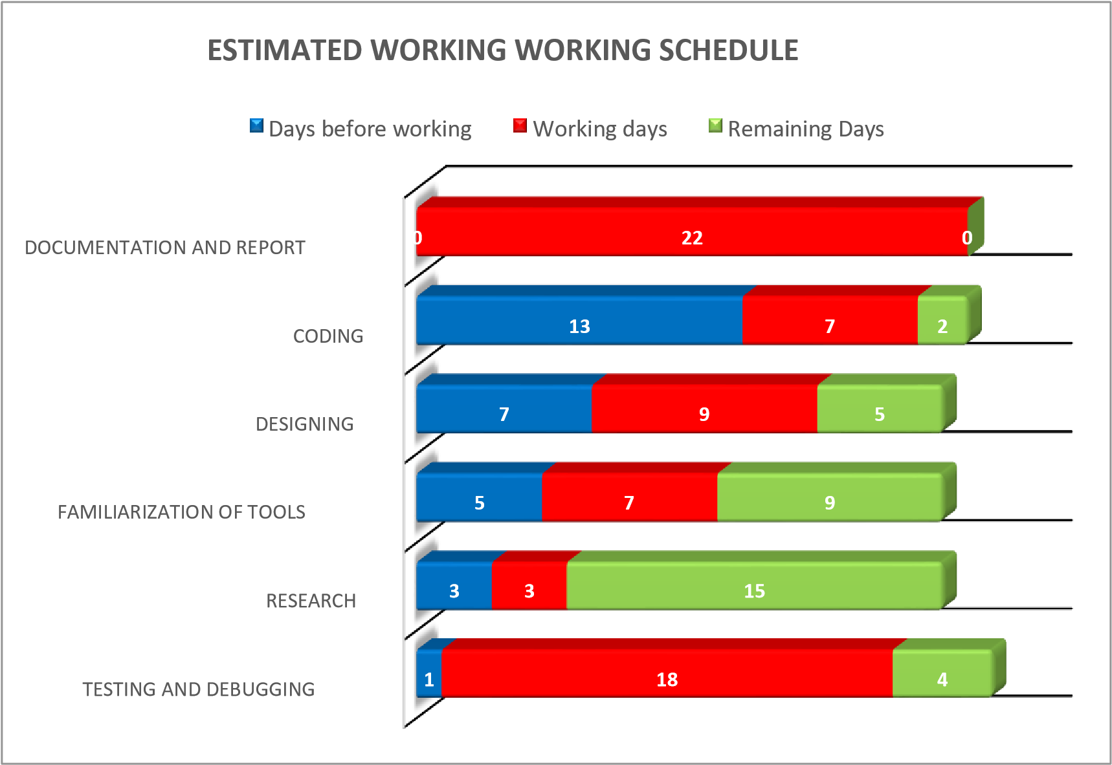

Fig 4.3 Chart showing estimated time for working schedule

**CHAPTER 5: REFERENCES**

1. E balagurusamy , “ Object Oriented programming with c++” Sixth Edition.
2. [http://www.wikipedia.org /](http://www.wikipedia.org/)wiki/literature review, 2019 jan 26
3. [http://www.departmental.com](http://www.departmental.com/)
4. <http://www.cppforschool.com/project/super-market-billing.html>